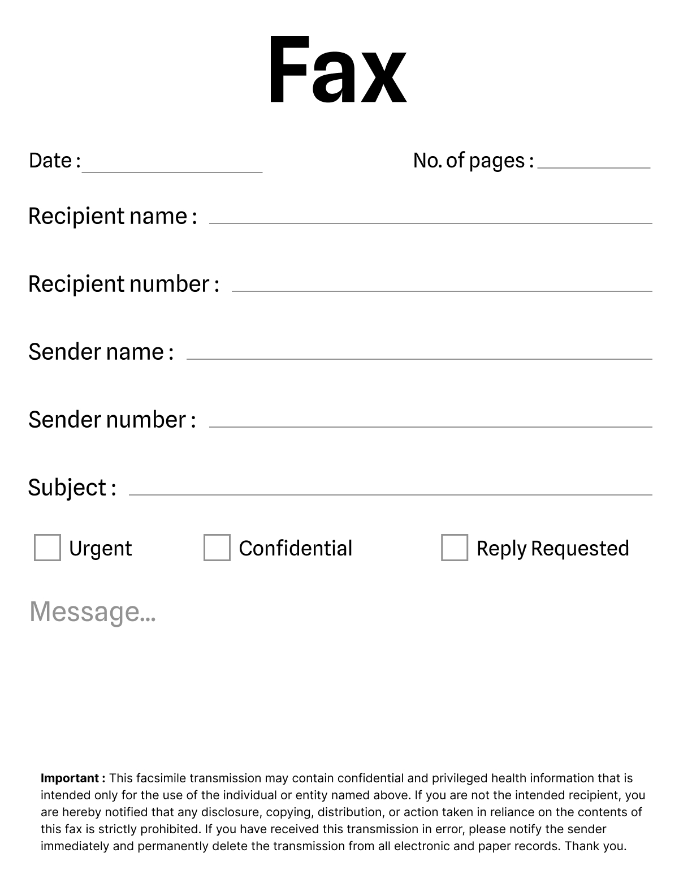

06/10/2024

2



W9 Form

Loma Linda University Health Plan

909-651-4010

Sachin Kumar

6202914041

incorrect it's po box 1753 jhonson city tn 37605 so need send w9 form to mail adress po box 1770 LOMA LINDA CA 92354